Milestone 2
CST-391
Chris Peterson

The idea for my milestone project is a database of sermons, tagged and organized for download. The sermons would be uploaded at the admin side while the general user can pick and download whatever they want.

As a visitor, I want to browse sermons by category so that I can find topics that interest me.
As a user, I want to search sermons by keyword, speaker, or scripture reference so that I can quickly locate relevant content.
As a user, I want to filter sermons by date, length, or topic so that I can narrow down my choices.
As a user, I want to download sermons from the website and listen to them offline, or stream them straight from the site.
As an Admin, I want do upload sermons to the database and add tags that the user finds useful, such as the date, length, and topic.

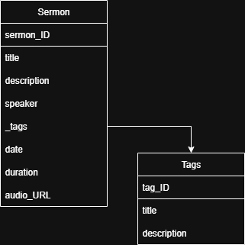
ER Diagram

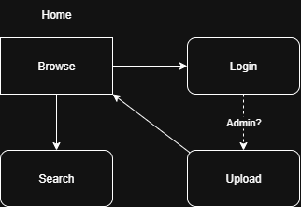
Site Diagram
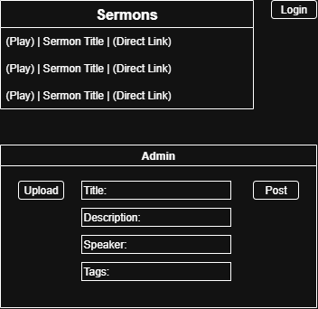
Wireframe

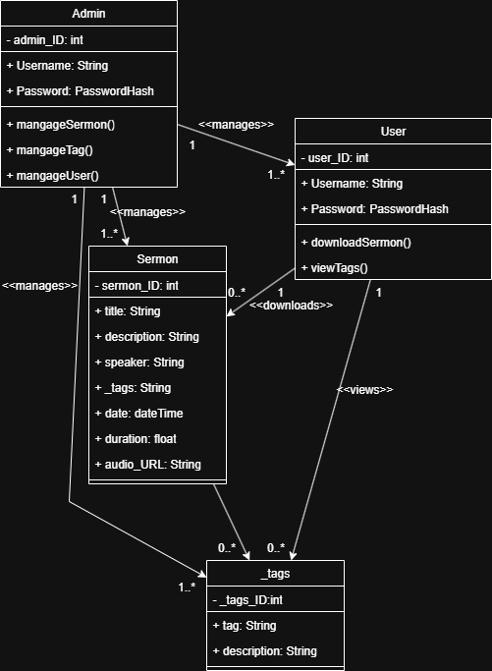
UML Diagrams

API Endpoints
1. GET /sermons
Purpose: Retrieve a list of sermons with optional filters
Query Parameters:
category: Filter by category name or ID
speaker: Filter by speaker name or ID
series: Filter by series name or ID
search: Keyword search in title or description
date: Filter by sermon date
2. GET /sermons/{id}
Purpose: Retrieve detailed information about a specific sermon
3. POST /users/{id}/favorites
Purpose: Add a sermon to a user's favorites
4. POST /users/{id}/downloads
Purpose: Record a sermon download for a user

